

A FRAMEWORK FOR A CENTRALISED HEALTH
RECORD MANAGEMENT SYSTEM

A PROJECT REPORT

Submitted by

AJITH KUMAR K | 720418104003
ARUNIMA KRISHNAKUMAR | 720418104009
S GEETHA | 720418104014
SANTHOSH AKILAN | 720418104018

in partial fulfillment for the award of the degree

of

BACHELOR OF ENGINEERING

in

COMPUTER SCIENCE AND ENGINEERING

CMS COLLEGE OF ENGINEERING AND TECHNOLOGY COIMBATORE

ANNA UNIVERSITY : CHENNAI 600 025

MAY 2022

i

ANNA UNIVERSITY : CHENNAI 600 025

BONAFIDE CERTIFICATE

Certified that this project report “ A FRAMEWORK FOR A CENTRALISED HEALTH RECORD MANAGEMENT SYSTEM ” is the bonafide work of “AJITH KUMAR K, ARUNIMA KRISHNAKUMAR, S GEETHA and SANTHOSH AKILAN” who carried out the project work under my supervision.

SIGNATURE

SIGNATURE

Dr. G. Chitra Ganapathy, M.E., Ph.D

Mr. Dinesh Kumar. S, M.E.

HEAD OF THE DEPARTMENT

SUPERVISOR

Professor,

Assistant Professor,

Department of Computer

Department of Computer

Science and Engineering,

Science and Engineering,

CMS College of Engineering and Technology,

CMS College of Engineering
and Technology,

Coimbatore-641 032

Coimbatore-641 032

Submitted for the Anna University Project Viva Voce conducted on

INTERNAL EXAMINER EXTERNAL EXAMINER

ii

ACKNOWLEDGEMENT

Any organized and systematic word calls for the corporation of team of people. Our project does not have any exception to this. Hence these pages find the space for thanking all those who have directly and indirectly contributed to completion of this work in a successful manner.

We record our indebtedness to our | Principal Dr. N. Sudha, M. Tech.,
Ph.D, for her guidance and sustained | encouragement for the successful
completion of this project.

We express our heartfelt thanks to Dr. G. Chitra Ganapathy, M.E., Ph.D, Professor and Head Of the Department, Department of the Computer Science and Engineering, CMS College of Engineering and Technology, for her encouragement and support in project work.

We express our heart full thanks to our guide Mr. Dinesh Kumar. S, M.E., Assistant Professor, Department of Computer Science and Engineering, CMS College of Engineering and Technology, for his encouragement and valuable guidance in carrying out our project work.

We are highly grateful to Dr. R. Kumar, M.E., Ph.D, Associate Professor, our project coordinator, Department of Computer Science and Engineering, CMS College of Engineering and Technology, for her encouragement during the course of work.

We are thankful to all technical and non-teaching staff of the Department of Computer Science and Engineering for their consistent assistance and co- operation. We also express thanks to our parents, friends for their encouragement and best wishes in the successful completion of this dissertation.

iii

ABSTRACT

This work is introducing a system that is used to reduce the manual work at Health centre counters. This system connects multiple authorized hospitals and every sort of task is performed by the system, such as registering different types of persons (employees, students and others), enquiries, and complaints etc. Thus, reducing much paper work and burden of file storage. Also, the latest information is right available for the officials and executives wherever they require. The system also facilitates the pharmacist to enquire about the drugs and about the stock to be ordered and about the expiry date. This system creates a platform supporting the new vision of health services that empowers patients and enables patient-provider communication, with the goal of improving health care outcomes and reducing cost.

iv
TABLE OF CONTENTS

CHAPTER |  | TITLE | PAGE
NO. |  |  | NO.
 | ACKNOWLEDGEMENT |  | iii
 | ABSTRACT |  | iv
 | LIST OF TABLES |  | vii
 | LIST OF FIGURES |  | viii
 | LIST OF ABBREVIATIONS |  | ix
1 | INTRODUCTION |  | 1
 | 1.1 | PURPOSE | 1
 | 1.2 | SCOPE | 1
 | 1.3 | OVERVIEW | 1
2 | LITERATURE REVIEW |  | 3
3 | SYSTEM ANALYSIS |  | 5
 | 3.1 | EXISTING SYSTEM | 5
 |  | 3.1.1 LIMITATIONS IN EXISTING | 6
 |  | SYSTEM
 | 3.2 | PROPOSED SYSTEM | 7
 |  | 3.2.1 ADVANTAGES OVER EXISTING
 |  | SYSTEM | 8
4 | SYSTEM REQUIREMENT & |  | 9
 | SPECIFICATION
 | 4.1 | SOFTWARE REQUIREMENTS | 9
 | 4.2 | HARDWARE REQUIREMENTS | 9
 | 4.3 | SOFTWARE STUDY | 10
 |  | 4.3.1 PHP

4.3.2 CODEIGNITER

4.3.3 XAMPP

v

5

6

7

SYSTEM IMPLEMENTATION |  | 15
5.1 | SYSTEM DESIGN | 15
 | 5.1.1 ARCHITECTURE DIAGRAM | 15
5.2 | SYSTEM FLOWCHART | 16
5.3 | IMPLEMENTATION | 17

SYSTEM TESTING |  |  |  | 20
6.1 | UNIT TESTING |  |  | 21
6.2 | INTEGRATION TESTING |  |  | 22
CONCLUSION |  |  |  | 23
APPENDIX |  | 1 | SOURCE CODE
APPENDIX |  | 2 | SCREEN SHOTS

REFERENCES

vi
LIST OF TABLES

TABLE NO. | TABLE NAME | PAGE NO.
6.1 | Unit Testing | 21
6.2 | Integration Testing | 22

vii

LIST OF FIGURES

FIG.NO. | FIGURE NAME | PAGE NO.
5.1 | System Architecture | 15
5.2 | System Flowchart | 16

viii

LIST OF ABBREVIATIONS

E ELECTRONIC

HSOS HEALTH CARE SYSTEM OF SYSTEMS

OHC ONLINE HEALTH CARE

MVC MODEL VIEW CONTROLLER

ix

CHAPTER 1

INTRODUCTION

1.1 PURPOSE

The purpose of this system is to create a platform supporting the new vision of health services that empowers patients and enables patient-provider communication, with the goal of improving health care outcomes and reducing cost.

1.2 SCOPE

This work aids in developing a E-Health records management system as from manual system to a centralised computerized system, and to take care of records of various hospitals.

1.3 OVERVIEW

Every day by day the data are increasing numerously. Thus, there is an extortionate need for maintaining an E- health records system. It reduces the burden of doing paper works manually as well as avoids the need of caring treatment history in handy. This system connects multiple hospitals and thus maintains the E- Records centralised. This system presents a health care system which has a transaction equates to patient’s hospital visits, administration documents, diagnoses reports, treatment details, physician’s prescriptions, laboratory results or reports, X-rays, outcomes etc. This paper is organized as follows. Section 2 describes background information about the working of health care system and applications of E- Health records. Section 3 explains the

1

various management levels involved to develop an efficient centralised health care management system. Section 4 explains the technologies used for the implementation.

2
CHAPTER 2

LITERATURE REVIEW

A detailed study on blockchain in E- Healthcare records management system is done. It helped in understanding the merits and demerits of using Blockchain in E- Healthcare records management system. In blockchain the data that is synced as a node is accessible as a sequence of block containing transactions. This way of accessing transaction data, however is too slow for applications that require a transaction graph to be constructed.
A study explains the efficient technique of serving and dictating medical health care to the patients with the point of maintaining privacy of the patient’s data and also about the process of laying out real time accurate and trusted data to the medical practitioners. Whereas in this scenario the primary concern arises is in the fact of privacy and security of the data of the patients due to the interoperability of multiple stakeholders in the process. It also accounts on the idea of using an appropriate medium for laying out accurate and trusted data for serving with deliberate medical care and benefits to the patients across.
A health care system of systems (HSOS) which can be defined as a collection of independent, largescale complex, distributed systems. As the healthcare systems are very diverse, distributed and complex systems in nature, it consists of a large number of stakeholders. To come out with a best design from the stakeholders it is very important to understand about the various key stakeholders in the healthcare system deeply.
As the importance of health care is immense in a society over the past years, this sector has been evolving to produce a more efficient and computerized system. While developing an Online Health Care (OHC) system, users can register as patients to store their medical data in the database. Using a CodeIgniter, a PHP framework along with database designed using MySQL and

3

XAMPP as the server provides an efficient way of storing information electronically, a faster communication mechanism between patients and doctors, and also it ensures better security for the users.
These health care has vital role in human lives especially for those who has some health issues and are seeking for a practical solution for a better life. This leads to a rapid increase in E- health technologies such as E-Health Records and some emergency detection and response methods. These are the advances that manages the challenges of smart health care in terms of security, sharing, integration and management.

4

CHAPTER 3

SYSTEM ANALYSIS

3.1 EXISTING SYSTEM

Existing system uses concepts of E- Health records to maintain an E- healthcare management system for each hospital distinctly. It provides facilities like storing patient’s personal details and prescriptions. These data are confined to respectively hospitals only. For checking the doctor’s availability, booking appointments etc people are forced to visit hospitals. Enquiry over telephone is also available in some hospitals.

These systems features and formats varies from hospital to hospital thus effects the possibility of sharing the patient’s prescription details from one hospital to another. Even now there are still some hospitals where even any of these kinds of systems doesn’t exist and still depends on the traditional way of keeping records.

5

3.1.1 LIMITATIONS IN EXISTING SYSTEM

- In the existing system patients are forced to carry their prescription and treatment history whenever they are visiting a new hospital.

- Facilities like checking doctor’s availability, schedule appointments are not available.

- Lack of knowledge about the patient’s body nature sometimes delays are faced in giving the proper treatments.

- Unmanageable number of prescriptions brings difficulty to the patient’s as well as doctors to manage.

6

3.2 PROPOSED SYSTEM

Proposed system makes use of centralization concept to connect various hospitals. Doctor’s prescriptions, X-ray and test reports, patient’s personal details etc are stored and can be retrieved efficiently and effectively. These data can be retrieved from anywhere. It provides various options like checking the availability in the blood bank, checking daily status etc.
To ensure efficiency database is designed using MySQL and XAMPP is used as the server. The features available to each users varies according to their authorization power. Every feature’s available for them can be avail from their dashboard. There will be a head for the system called as “Super Admin” who has control over all the peers and is responsible for maintaining the smooth working of the whole system. The highest authority of each hospital is called as “Admin”. It is the responsibility of the admin to maintain a smooth functioning in their hospital. Patient’s can login to their dashboard to see their descriptions, treatment history and payment details. Doctor’s can also login under their hospital to check their patient’s list, appointments on each date etc.

7

3.2.1 ADVANTAGES OF PROPOSED SYSTEM

- Reduces the burden of patient’s in caring their treatment history with them handy.

- Provides them the benefit of visiting any hospital irrespective of place to follow up the treatment.

- As multiple hospitals are connected the patient’s need not to memorize their history of diseases and treatments taken each time while visiting a new hospital.

- Doctors could easily analyse the patient’s body nature thus provide them relevant treatments on time.

8

CHAPTER 4

SYSTEM REQUIREMENT &

SPECIFICATION

4.1 SOFTWARE REQUIREMENTS

Operating System | : WINDOWS 10
XAMPP | : 7.4.29
CodeIgniter | : v4

4.2 HARDWARE REQUIREMENTS

Processors | : Intel core i5
Hard Disk | : 250GB
RAM | : | 4 GB(minimum)

9

4.3 SOFTWARE STUDY

4.3.1 PHP
PHP is an open-source, interpreted, and object-oriented scripting language that can be executed at the server-side. PHP is well suited for web development. Therefore, it is used to develop web applications (an application that executes on the server and generates the dynamic page.).
PHP was created by Rasmus Lerdorf in 1994 but appeared in the market in 1995. PHP 7.4.0 is the latest version of PHP, which was released on 28 November. Some important points need to be noticed about PHP are as followed:
- PHP stands for Hypertext Pre-processor.
- It is an interpreted language, which means there is no need for compilation.
- It is faster than other scripting languages like ASP and JSP.
- It is a server-side scripting language, which is used to manage the dynamic content of the website.
- PHP can be embedded into HTML.
- It is simple and easy to learn language.
Although most web developers have a range of scripting languages, such as CGI, ASP, JSP, and Perl, most tend to favour PHP. There are several reasons why this programming language is at the forefront of website development:
- Easy and Simple to Learn
PHP is considered one of the easiest scripting languages. Compared to other web languages, PHP doesn’t require a manual or intensive studying. PHP syntax is logical and well-organized. Even command functions are easy to understand, as they tell the developer what function they perform.
10

As a result, web developers find it very easy to create and optimize the application.
- Extremely Flexible
PHP is highly flexible whether it is during an ongoing project or after completing the project. Flexibility in a scripting language is very crucial, as functionality can change anytime during the course of a project. The best part about PHP is the ability to make changes even after starting the project and this saves valuable time. A developer does not have to write fresh codes or command functions, as changes to the existing codes and functions can be done and used.
- Easy Integration and Compatibility
PHP is compatible with a large majority of operating systems. It can easily run on different platforms, including UNIX, Solaris and Linux. As it can be integrated without effort with other technologies, such as Java where existing software does not require re-development. This saves time and money.
- Efficient Performance
Depending on how the web developer codes, PHP has the potential to turn in an efficient language. It is scalable when used for writing codes and can also be used for creating a large number of applications. It is the programming language of choice when a website has several web pages.
- Cost Efficient
PHP is an open-source web language, hence is completely free. There is no expense involved in purchasing expensive licenses or software. It can
11

work efficiently with different databases, such as MySQL, Apache and
PostgreSQL. The cost of developing a website using PHP is minimal.

- Gives Web Developer More Control
Compared to other programming languages, PHP allows the website developer to have more control. Other programming languages are bogged down by long, complicated scripts, but this isn’t true for PHP. A few simple lines of code are sufficient. Furthermore, PHP allows tags, and hence, website developers can add or mix HTML tags, making the content extremely dynamic. Developers don’t have to worry about placing the codes in the right place when using PHP, as it is written between tags. Hence, functions and codes do not have to be written in any specific order, as long as they are within the tags.

4.3.2 CodeIgniter
CodeIgniter is a powerful PHP framework with a very small footprint, built for developers who need a simple and elegant toolkit to create full-featured web applications. CodeIgniter was created by EllisLab, and is now a project of the British Columbia Institute of Technology.
It provides out of the box libraries for connecting to the database and performing various operations like sending emails, uploading files, managing sessions, etc. It is an MVC framework. When a user requests a resource, the controller responds first. The controller understands the user request then request the necessary data if necessary. Various features are:
- Small Footprint
The entire code for CodeIgniter framework is close to 2 MB. This
makes it easy to master CodeIgniter and how it works. It also simplifies
deploying and updating it.

12
- Blazing fast
Users tend to favour applications that load very fast. If you have worked
with some of the modern frameworks, then you will realize that they take
less than one second to load just after installation. CodeIgniter, you can
load on average around less than 50ms. The extra time spent optimizing
like is the case in another framework is freed up when you are working
with this framework.

4.3.3 XAMPP
XAMPP is a free and open-source cross-platform web server solution stack package developed by Apache friends, consisting mainly of the Apache HTTP Server, MariaDB database and interpreters for scripts written in PHP and Perl Programming languages. Once XAMPP is installed, it is possible to treat a localhost like a remote host by connecting using an FTP client.
XAMPP has the ability to serve web pages on the World Wide Web. A special tool is provided to password-protect the most important parts of the package. XAMPP also provides support for creating and manipulating databases in MariaDB and SQLite among others.

13

CHAPTER 5

SYSTEM IMPLEMENTATION

5.1 SYSTEM DESIGN

5.1.1 Architecture Diagram

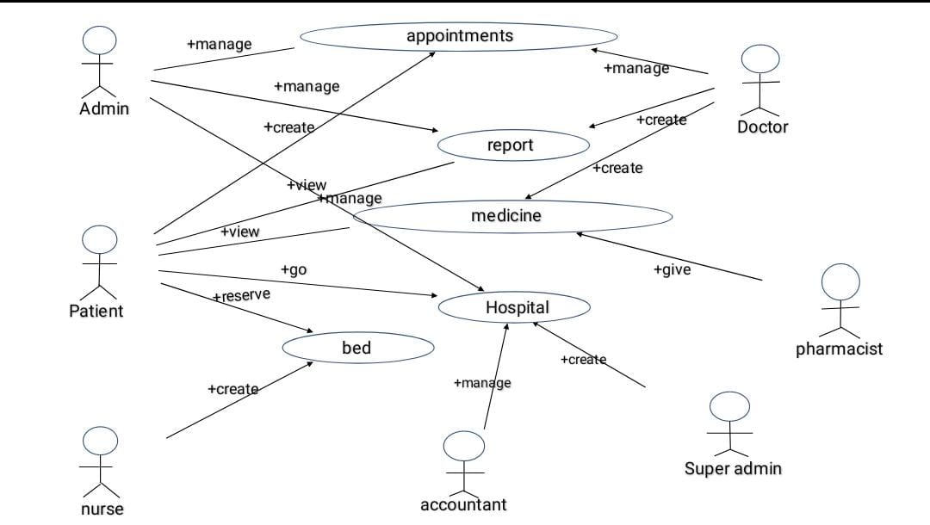

Figure.5.1 System Architecture

14

5.2 SYSTEM FLOWCHART

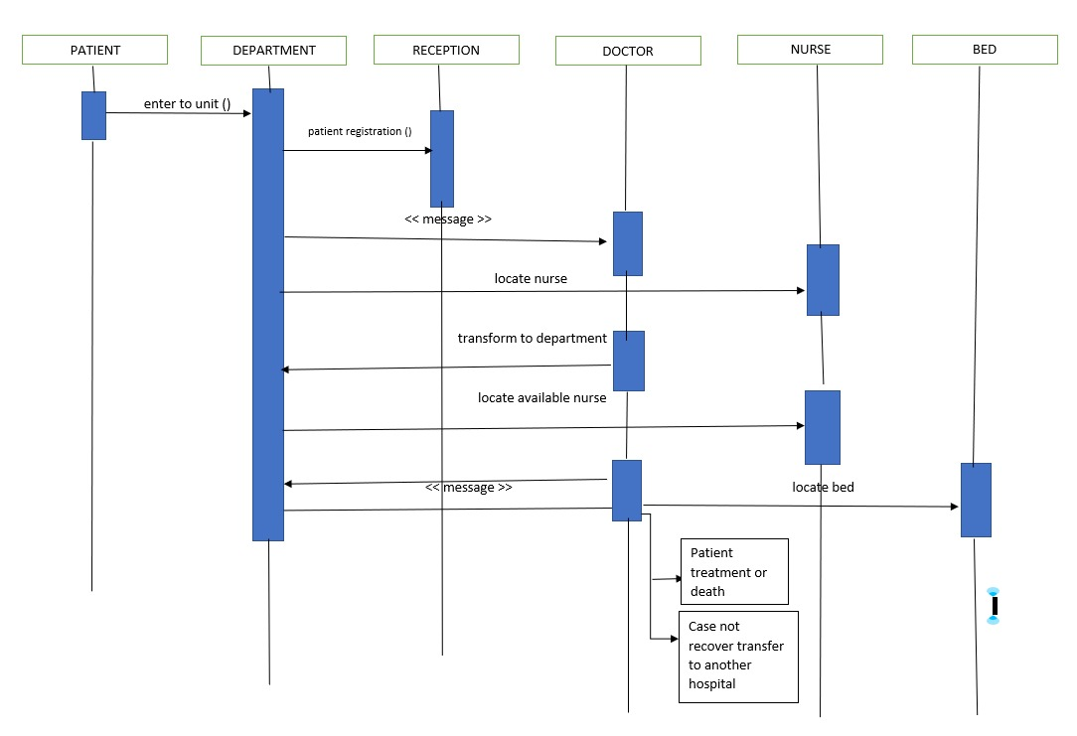

Figure.5.2 System Flowchart

15

5.3 IMPLEMENTATION

The system design model is tested functionally in different levels:
- First set up the environment. Here we are using XAMPP as the server and CodeIgniter framework of PHP to build the project.
- Once the environment is set. Now a database file is created called “database_table”. The database is designed using MySQL. Various necessary fields are created and values are inserted.
- Then the website is created using the CodeIgniter framework of PHP. Using the concept of modular programming the coding phase is divided into 5 modules and are developed to produce the required outcome. The modules are listed below
- Super Admin:
- It is the highest authority of this system.
- Request from admins of each hospital is verified and approved by the super admin.
- Super Admin controls the features that can be used by the hospitals.
- Admin:
- Admin is the highest authority of management in the hospital.
- Doctors, nurses and all other staffs comes under the admin.
- Requests for being part in this healthcare management system is done by the admins on behalf of the hospital.
- Doctor:
- Doctors will have the facility to mark their availability that could be noted by patients to book their appointments.
- Prescription of each patient are uploaded by the doctor in their respective profile. Along that the doctor can view the patient history to follow up.

16

- Lab reports of the respective patient are also visible for the doctor to diagnose the disease.
- Nurse:
- Nurses can allot bed for the patients. They can also inspect the bed number of each patient admitted.
- Blood bank details and availability are updated by the nurses.
- Doctors schedule are provided in this module for nurses to follow and ensure best service.
- Patient:
- Patients can check their test reports and appointment status.
- Prescriptions by the doctor, test reports, case history etc are provided in their respective dashboard for reference.
- Details such as address, phone number, blood group etc are also provided in their profile to ensure efficient communication.
- Once the modules are developed, place the file in “htdocs” of Xampp to connect with localhost.

17

CHAPTER 6

SYSTEM TESTING

Software testing is an investigation conducted to provide stakeholders with information of the quality of the product or service under test. Software testing can also provide an objective, independent view of the software to allow the business to appreciate and understand the risk of software implementation. Test techniques include, but are not limited to, the process of executing a program are application with the intent of finding software bugs (errors or other defects).

Software testing can be stated as the process of validating and verifying that a computer program/application/product:

- Meets the requirements that guided its design and development,

- Works as expected,

- Can be implemented with the same characteristics,

- And satisfies the needs of stakeholders

Software testing, depending on the testing method employed, can be implemented at any time in the development process. Traditionally, most of the test effort occurs after the requirements have been defined and the coding process has been completed, but in the agile approaches most of the test effort is ongoing. As such, the methodology of the test is governed by the chosen software development methodology.

Different software development models will focus the test effort at different points in the development process, newer development models such as agile, often employ test driven development and place an increased portion of the testing in the hands of the developer, before it reaches a formal team of testers.

18

6.1 UNIT TESTING

Dataset pre-processing the unit testing, also known as component testing refers to tests that verify the functionality of a specific section of code, usually at the function level. These types of tests are usually written by developers as they work on code (white box style), to ensure that the specific function is working as expected. One function might have multiple tests, to catch corner cases or other branches in the code. During testing alone, cannot verify the functionality of a piece of software, but rather is used to assure that the building blocks the software uses work independently of each other.

In this module, the dataset can be collected from the domain and then pre-processes it and store in to database in the table format to simplify the search process. The unit testing is applied to this module to test whether the functionality of collecting the dataset and storing it into table in the database has been done correctly.

CASE NO. | DESCRIPTION | EXPECTED RESULTS

1 | To check for all syntax and logical | No errors are found.
 | errors.

Table No 6.1 Unit Testing

19

6.2 INTEGRATION TESTING

Objective of this integration testing is to test the module interface in order to ensure that there are no errors in the parameter passing when one module involves the other module. It is tested in our project when the main function calls of the other sub functions.

It is a systematic technique for constructing program structure while at the same time conducting test to uncover error associated with interface. Here, we go for the top-down approach. It is also known as Incremental Approach for the construction of program structure.

CASE NO. | DESCRIPTION | EXPECTED RESULTS
1 | To examine all the modules are | All the modules are
 | integrated or not. | integrated through main
 |  | function.

Table No 6.2 Integration Testing

20

CHAPTER 7

CONCLUSION

The proposed work is designed to maintain a centralised health care management system by connecting multiple hospitals. It reduces the burden of people in caring reports, prescriptions etc as hard copy. The biggest benefit of this system is that it makes the process of visiting new hospital at ease. It provides various features like booking appointments, checking doctor’s availability, blood bank availability. These features bring great impact on the society in terms of health care management. Since we are entering details of the patients electronically in this system, data will be secured. Using this website, we can retrieve patient’s history with a single click. Thus, processing information will be faster. It guarantees accurate maintenance of patient details. It easily reduces the book keeping task and thus reduces the human effort and increases accuracy and speed.

Future Enhancement

In the future this kind of system can be used widely to maintain an efficient health care system. It can be used for an area, a city, a state or even a country.
Thus, it will help to maintain a centralised health care system everywhere. As new technologies are emerging day by day, there will be more chances to build a secured as well as advanced system.

21

APPENDIX 1

SOURCECODE

Doctor.php

<?php
if (!defined('BASEPATH'))
exit('No direct script access allowed');
class Doctor extends MX_Controller {
function __construct() {
parent::__construct();
$this->load->model('doctor_model');
$this->load->model('department/department_model');
$this->load->model('appointment/appointment_model');
$this->load->model('patient/patient_model');
$this->load->model('prescription/prescription_model');
$this->load->model('schedule/schedule_model');
$this->load->module('patient');
if (!$this->ion_auth->in_group(array('admin', 'Accountant', 'Doctor'))) {
redirect('home/permission');
}
}
public function index() {
$data['doctors'] = $this->doctor_model->getDoctor();
$data['departments'] = $this->department_model->getDepartment();
$this->load->view('home/dashboard'); // just the header file
$this->load->view('doctor', $data);
$this->load->view('home/footer'); // just the header file
}

22

public function addNewView() {
$data = array();
$data['departments'] = $this->department_model->getDepartment();
$this->load->view('home/dashboard'); // just the header file
$this->load->view('add_new', $data);
$this->load->view('home/footer'); // just the header file
}
public function addNew() {
$id = $this->input->post('id');
if (empty($id)) {
$limit = $this->doctor_model->getLimit();
if ($limit <= 0) {
$this->session->set_flashdata('feedback', lang('doctor_limit_exceed'));
redirect('doctor');
}
}
$name = $this->input->post('name');
$password = $this->input->post('password');
$email = $this->input->post('email');
$address = $this->input->post('address');
$phone = $this->input->post('phone');
$department = $this->input->post('department');
$profile = $this->input->post('profile');
$this->load->library('form_validation');
$this->form_validation->set_error_delimiters('<div class="error">', '</div>');
// Validating Name Field
$this->form_validation->set_rules('name', 'Name', 'trim|required|min_length[1]|max_length[100]|xss_clean');

23
// Validating Password Field
if (empty($id)) {
$this->form_validation->set_rules('password', 'Password', 'trim|required|min_length[5]|max_length[100]|xss_clean');
}
// Validating Email Field
$this->form_validation->set_rules('email', 'Email', 'trim|required|min_length[5]|max_length[100]|xss_clean');
// Validating Address Field
$this->form_validation->set_rules('address', 'Address', 'trim|required|min_length[1]|max_length[500]|xss_clean');
// Validating Phone Field
$this->form_validation->set_rules('phone', 'Phone', 'trim|required|min_length[1]|max_length[50]|xss_clean');
// Validating Department Field
$this->form_validation->set_rules('department', 'Department', 'trim|required|min_length[1]|max_length[500]|xss_clean');
// Validating Phone Field
$this->form_validation->set_rules('profile', 'Profile', 'trim|required|min_length[1]|max_length[50]|xss_clean');
if ($this->form_validation->run() == FALSE) {
if (!empty($id)) {
$data = array();
$data['departments'] = $this->department_model->getDepartment();
$data['doctor'] = $this->doctor_model->getDoctorById($id);
$this->load->view('home/dashboard'); // just the header file
$this->load->view('add_new', $data);
$this->load->view('home/footer'); // just the footer file
} else {

24
$data = array();
$data['setval'] = 'setval';
$data['departments'] = $this->department_model->getDepartment();
$this->load->view('home/dashboard'); // just the header file
$this->load->view('add_new', $data);
$this->load->view('home/footer'); // just the header file
}
} else {
$file_name = $_FILES['img_url']['name'];
$file_name_pieces = explode('_', $file_name);
$new_file_name = '';
$count = 1;
foreach ($file_name_pieces as $piece)
if ($count !== 1) {
$piece = ucfirst($piece);
}
$new_file_name .= $piece;
$count++;
}
$config = array(
'file_name' => $new_file_name,
'upload_path' => "./uploads/",
'allowed_types' => "gif|jpg|png|jpeg|pdf",
'overwrite' => False,
'max_size' => "20480000", // Can be set to particular file size , here it is 2 MB(2048 Kb)
'max_height' => "1768",
'max_width' => "2024"
);
$this->load->library('Upload', $config);
25
$this->upload->initialize($config);
if ($this->upload->do_upload('img_url')) {
$path = $this->upload->data();
$img_url = "uploads/" . $path['file_name'];
$data = array();
$data = array(
'img_url' => $img_url,
'name' => $name,
'email' => $email,
'address' => $address,
'phone' => $phone,
'department' => $department,
'profile' => $profile
);
} else {
//$error = array('error' => $this->upload->display_errors());
$data = array();
$data = array(
'name' => $name,
'email' => $email,
'address' => $address,
'phone' => $phone,
'department' => $department,
'profile' => $profile
);
}
$username = $this->input->post('name');
if (empty($id)) { // Adding New Doctor
if ($this->ion_auth->email_check($email)) {
$this->session->set_flashdata('feedback', 'This Email Address Is
26
Already Registered');
redirect('doctor/addNewView');
} else {
$dfg = 4;
$this->ion_auth->register($username, $password, $email, $dfg);
$ion_user_id = $this->db->get_where('users', array('email' => $email))->row()->id;
$this->doctor_model->insertDoctor($data);
$doctor_user_id = $this->db->get_where('doctor', array('email' => $email))->row()->id
$id_info = array('ion_user_id' => $ion_user_id);
$this->doctor_model->updateDoctor($doctor_user_id, $id_info);
$this->hospital_model->addHospitalIdToIonUser($ion_user_id, $this->hospital_id);
$this->session->set_flashdata('feedback', 'Added');
}
} else { // Updating Doctor
$ion_user_id = $this->db->get_where('doctor', array('id' => $id))->row()->ion_user_id;
if (empty($password)) {
$password = $this->db->get_where('users', array('id' => $ion_user_id))->row()->password;
} else {
$password = $this->ion_auth_model->hash_password($password);
}
$this->doctor_model->updateIonUser($username, $email, $password, $ion_user_id);
$this->doctor_model->updateDoctor($id, $data);
$this->session->set_flashdata('feedback', 'Updated');
}
27

// Loading View
redirect('doctor');
}
}
function editDoctor() {
$data = array();
$data['departments'] = $this->department_model->getDepartment();
$id = $this->input->get('id');
$data['doctor'] = $this->doctor_model->getDoctorById($id);
$this->load->view('home/dashboard'); // just the header file
$this->load->view('add_new', $data);
$this->load->view('home/footer'); // just the footer file
}
function details() {
$data = array();
if ($this->ion_auth->in_group(array('Doctor'))) {
$doctor_ion_id = $this->ion_auth->get_user_id();
$id = $this->doctor_model->getDoctorByIonUserId($doctor_ion_id)->id;
} else {
redirect('home');
}
$data['doctor'] = $this->doctor_model->getDoctorById($id);
$data['todays_appointments'] = $this->appointment_model->getAppointmentByDoctorByToday($id);
$data['appointments'] = $this->appointment_model->getAppointmentByDoctor($id);
$data['patients'] = $this->patient_model->getPatient();
$data['appointment_patients'] = $this->patient-

28
>getPatientByAppointmentByDctorId($id);
$data['doctors'] = $this->doctor_model->getDoctor();
$data['prescriptions'] = $this->prescription_model-
>getPrescriptionByDoctorId($id);
$data['holidays'] = $this->schedule_model->getHolidaysByDoctor($id);
$data['schedules'] = $this->schedule_model->getScheduleByDoctor($id);
$this->load->view('home/dashboard'); // just the header file
$this->load->view('details', $data);
$this->load->view('home/footer'); // just the footer file
}
function editDoctorByJason() {
$id = $this->input->get('id');
$data['doctor'] = $this->doctor_model->getDoctorById($id);
echo json_encode($data);
}
function delete() {
$data = array();
$id = $this->input->get('id');
$user_data = $this->db->get_where('doctor', array('id' => $id))->row();
$path = $user_data->img_url;
if (!empty($path)) {
unlink($path);
}
$ion_user_id = $user_data->ion_user_id;
$this->db->where('id', $ion_user_id);
$this->db->delete('users');
$this->doctor_model->delete($id);
$this->session->set_flashdata('feedback', 'Deleted');
redirect('doctor');
}
29
function getDoctor() {
$requestData = $_REQUEST;
$start = $requestData['start'];
$limit = $requestData['length'];
$search = $this->input->post('search')['value'];
if ($limit == -1) {
if (!empty($search)) {
$data['doctors'] = $this->doctor_model->getDoctorBysearch($search);
} else {
$data['doctors'] = $this->doctor_model->getDoctor();
}
} else {
if (!empty($search)) {
$data['doctors'] = $this->doctor_model->getDoctorByLimitBySearch($limit, $start, $search);
} else {
$data['doctors'] = $this->doctor_model->getDoctorByLimit($limit, $start);
}
}
// $data['doctors'] = $this->doctor_model->getDoctor();
foreach ($data['doctors'] as $doctor) {
if ($this->ion_auth->in_group(array('admin', 'Accountant', 'Receptionist'))) {
$options1 = '<a type="button" class="btn btn-info btn-xs btn_width editbutton" title="' . lang('edit') . '" data-toggle="modal" data-id="' . $doctor->id . '"><i class="fa fa-edit"> </i> ' . lang('edit') . '</a>';
// $options1 = '<a class="btn btn-info btn-xs btn_width" title="' . lang('edit') . '" href="doctor/editDoctor?id='.$doctor->id.'"><i class="fa fa-edit"> </i> ' . lang('edit') . '</a>';
}
30
$options2 = '<a class="btn btn-info btn-xs detailsbutton" title="' . lang('appointments') . '" href="appointment/getAppointmentByDoctorId?id=' . $doctor->id . '"> <i class="fa fa-calendar"> </i> ' . lang('appointments') . '</a>';
if ($this->ion_auth->in_group(array('admin', 'Accountant', 'Receptionist'))) {
$options3 = '<a class="btn btn-info btn-xs btn_width delete_button" title="' . lang('delete') . '" href="doctor/delete?id=' . $doctor->id . '" onclick="return confirm(\'Are you sure you want to delete this item?\');"><i class="fa fa-trash-o"> </i> ' . lang('delete') . '</a>';
}
if ($this->ion_auth->in_group(array('admin', 'Accountant', 'Receptionist'))) {
$options4 = '<a href="schedule/holidays?doctor=' . $doctor->id . '" class="btn btn-info btn-xs btn_width" data-toggle="modal" data-id="' . $doctor->id . '"><i class="fa fa-book"></i> ' . lang('holiday') . '</a>';
$options5 = '<a href="schedule/timeSchedule?doctor=' . $doctor->id . '" class="btn btn-info btn-xs btn_width" data-toggle="modal" data-id="' . $doctor->id . '"><i class="fa fa-book"></i> ' . lang('time_schedule') . '</a>';
$options6 = '<a type="button" class="btn btn-info btn-xs btn_width detailsbutton inffo" title="' . lang('info') . '" data-toggle="modal" data-id="' . $doctor->id . '"><i class="fa fa-info"> </i> ' . lang('info') . '</a>';
}
$info[] = array(
$doctor->id,
$doctor->name,
$doctor->email,
$doctor->phone,
$doctor->department,
$doctor->profile,

31
// $options1 . ' ' . $options2 . ' ' . $options3
$options6 . ' ' . $options1 . ' ' . $options2 . ' ' . $options4 . ' ' . $options5 . ' ' . $options3,
// $options2
);
}
if (!empty($data['doctors'])) {
$output = array(
"draw" => intval($requestData['draw']),
"recordsTotal" => $this->db->get('doctor')->num_rows(),
"recordsFiltered" => $this->db->get('doctor')->num_rows(),
"data" => $info
);
} else {
$output = array(
// "draw" => 1,
"recordsTotal" => 0,
"recordsFiltered" => 0,
"data" => []
);
}
echo json_encode($output);
}
}

Hospital.php:

?php
if (!defined('BASEPATH'))
exit('No direct script access allowed')
32
class Hospital extends MX_Controller {
function __construct() {
parent::__construct();
$this->load->model('hospital_model');
$this->load->model('hospital/package_model');
$this->load->model('donor/donor_model');
$this->load->model('pgateway/pgateway_model');
$this->load->model('sms/sms_model');
$this->load->model('email/email_model');
if (!$this->ion_auth->in_group('superadmin')) {
redirect('home/permission');
}
}
public function index() {
$data['hospitals'] = $this->hospital_model->getHospital();
$data['packages'] = $this->package_model->getPackage();
$this->load->view('home/dashboard'); // just the header file
$this->load->view('hospital', $data);
$this->load->view('home/footer'); // just the header file
}
public function addNewView() {
$data['packages'] = $this->package_model->getPackage();
$this->load->view('home/dashboard'); // just the header file
$this->load->view('add_new', $data);
$this->load->view('home/footer'); // just the header file
}
public function addNew() {
$id = $this->input->post('id');
$name = $this->input->post('name');

33
$password = $this->input->post('password');
$email = $this->input->post('email');
$address = $this->input->post('address');
$phone = $this->input->post('phone');
$package = $this->input->post('package');
$language = $this->input->post('language');
if (!empty($package)) {
$module = $this->package_model->getPackageById($package)->module;
$p_limit = $this->package_model->getPackageById($package)->p_limit;
$d_limit = $this->package_model->getPackageById($package)->d_limit;
} else {
$p_limit = $this->input->post('p_limit');
$d_limit = $this->input->post('d_limit');
$module = $this->input->post('module');
if (!empty($module)) {
$module = implode(',', $module);
}
}
$language_array = array('english', 'arabic', 'spanish', 'french', 'italian', 'portuguese');
if (!in_array($language, $language_array)) {
$language = 'english';
}
$this->load->library('form_validation');
$this->form_validation->set_error_delimiters('<div class="error">', '</div>');

34
// Validating Name Field
$this->form_validation->set_rules('name', 'Name', 'trim|required|min_length[5]|max_length[100]|xss_clean');
// Validating Password Field
if (empty($id)) {
$this->form_validation->set_rules('password', 'Password', 'trim|required|min_length[5]|max_length[100]|xss_clean');
}
// Validating Email Field
$this->form_validation->set_rules('email', 'Email', 'trim|required|min_length[5]|max_length[100]|xss_clean');
// Validating Address Field
$this->form_validation->set_rules('address', 'Address', 'trim|required|min_length[5]|max_length[500]|xss_clean');
// Validating Phone Field
$this->form_validation->set_rules('phone', 'Phone', 'trim|required|min_length[5]|max_length[50]|xss_clean');
// Validating Phone Field
$this->form_validation->set_rules('p_limit', 'Patient Limit', 'trim|required|min_length[1]|max_length[100]|xss_clean');
// Validating Phone Field
$this->form_validation->set_rules('language', 'Language', 'trim|required|min_length[1]|max_length[50]|xss_clean');
if ($this->form_validation->run() == FALSE) {
if (!empty($id)) {
redirect("hospital/editHospital?id=$id");
} else {
$data['packages'] = $this->package_model->getPackage();
$this->load->view('home/dashboard'); // just the header file

35
$this->load->view('add_new', $data);
$this->load->view('home/footer'); // just the header file
}
} else {
//$error = array('error' => $this->upload->display_errors());
$data = array();
$data = array(
'name' => $name,
'email' => $email,
'address' => $address,
'phone' => $phone,
'package' => $package,
'p_limit' => $p_limit,
'd_limit' => $d_limit,
'module' => $module
);
$username = $this->input->post('name');
if (empty($id)) { // Adding New Hospital
if ($this->ion_auth->email_check($email)) {
$this->session->set_flashdata('feedback', 'This Email Address Is Already Registered');
redirect('hospital/addNewView');
} else {
$dfg = 11;
$this->ion_auth->register($username, $password, $email, $dfg);
$ion_user_id = $this->db->get_where('users', array('email' => $email))->row()->id;
$this->hospital_model->insertHospital($data);
$hospital_user_id = $this->db->get_where('hospital', array('email'

36
=> $email))->row()->id;
$id_info = array('ion_user_id' => $ion_user_id);
$this->hospital_model->updateHospital($hospital_user_id, $id_info);
$hospital_settings_data = array();
$hospital_settings_data = array('hospital_id' => $hospital_user_id,
'title' => $name,
'email' => $email,
'address' => $address,
'phone' => $phone,
'language' => $language,
'system_vendor' => 'Code Aristos | Hospital management System',
'discount' => 'flat',
'currency' => '$'
);
$this->settings_model->insertSettings($hospital_settings_data);
$hospital_blood_bank = array();
$hospital_blood_bank = array('A+' => '0 Bags', 'A-' => '0 Bags', 'B+' => '0 Bags', 'B-' => '0 Bags', 'AB+' => '0 Bags', 'AB-' => '0 Bags', 'O+' => '0 Bags', 'O-' => '0 Bags');
foreach ($hospital_blood_bank as $key => $value) {
$data_bb = array('group' => $key, 'status' => $value, 'hospital_id' => $hospital_user_id);
$this->donor_model->insertBloodBank($data_bb);
$data_bb = NULL;
}
$data_sms_clickatell = array();
$data_sms_clickatell = array(
'name' => 'Clickatell',
37
'username' => 'Your ClickAtell Username',
'password' => 'Your ClickAtell Password',
'api_id' => 'Your ClickAtell Api Id',
'user' => $this->ion_auth->get_user_id(),
'hospital_id' => $hospital_user_id
);
$this->sms_model->addSmsSettings($data_sms_clickatell);
$data_sms_msg91 = array(
'name' => 'MSG91',
'username' => 'Your MSG91 Username',
'api_id' => 'Your MSG91 API ID',
'authkey' => 'Your MSG91 Auth Key',
'user' => $this->ion_auth->get_user_id(),
'hospital_id' => $hospital_user_id
);
$this->sms_model->addSmsSettings($data_sms_msg91);
$data_pgateway_paypal = array(
'name' => 'PayPal', // Sandbox / testing mode option.
'APIUsername' => 'PayPal API Username', // PayPal API username of the API caller
'APIPassword' => 'PayPal API Password', // PayPal API password of the API caller
'APISignature' => 'PayPal API Signature', // PayPal API signature of the API caller
'status' => 'test',
'hospital_id' => $hospital_user_id
);
$this->pgateway_model->addPaymentGatewaySettings($data_pgateway_paypal);

38
$data_pgateway_payumoney = array(
'name' => 'Pay U Money', // Sandbox / testing mode option.
'merchant_key' => 'Merchant key', // PayPal API username of the API caller
'salt' => 'Salt', // PayPal API password of the API caller
'status' => 'test',
'hospital_id' => $hospital_user_id
);
$this->pgateway_model->addPaymentGatewaySettings($data_pgateway_payumoney);
$data_email_settings = array(
'admin_email' => 'Admin Email', // Sandbox / testing mode option.
'hospital_id' => $hospital_user_id
);
$this->email_model->addEmailSettings($data_email_settings);
$this->session->set_flashdata('feedback', 'New Hospital Created');
redirect('hospital');
}
} else { // Updating Hospital
$ion_user_id = $this->db->get_where('hospital', array('id' => $id))->row()->ion_user_id;
if (empty($password)) {
$password = $this->db->get_where('users', array('id' => $ion_user_id))->row()->password;
} else {
$password = $this->ion_auth_model->hash_password($password);
}
$this->hospital_model->updateIonUser($username, $email, $password, $ion_user_id);

39
$this->hospital_model->updateHospital($id, $data);
$hospital_settings_data = array();
$hospital_settings_data = array(
'language' => $language
);
$this->settings_model->updateHospitalSettings($id, $hospital_settings_data);
$this->session->set_flashdata('feedback', 'Updated');
redirect('hospital/editHospital?id=' . $id);
}
}
}
function getHospital() {
$data['hospitals'] = $this->hospital_model->getHospital();
$this->load->view('hospital', $data);
}
function activate() {
$hospital_id = $this->input->get('hospital_id');
$data = array('active' => 1);
$this->hospital_model->activate($hospital_id, $data);
$this->session->set_flashdata('feedback', 'Activated');
redirect('hospital');
}
function deactivate() {
$hospital_id = $this->input->get('hospital_id');
$data = array('active' => 0);
$this->hospital_model->deactivate($hospital_id, $data);
$this->session->set_flashdata('feedback', 'Deactivated');
redirect('hospital');
}
40
function editHospital() {
$data = array();
$id = $this->input->get('id');
$data['packages'] = $this->package_model->getPackage();
$data['hospital'] = $this->hospital_model->getHospitalById($id);
$this->load->view('home/dashboard'); // just the header file
$this->load->view('add_new', $data);
$this->load->view('home/footer'); // just the footer file
}
function editHospitalByJason() {
$id = $this->input->get('id');
$data['hospital'] = $this->hospital_model->getHospitalById($id);
$data['settings'] = $this->settings_model->getSettingsByHId($id);
echo json_encode($data);
}
function delete() {
$data = array();
$id = $this->input->get('id');
$user_data = $this->db->get_where('hospital', array('id' => $id))->row();
$ion_user_id = $user_data->ion_user_id;
$this->db->where('id', $ion_user_id);
$this->db->delete('users');
$this->hospital_model->delete($id);
redirect('hospital');
}
}

- 41

APPENDIX
SCREENSHOTS

Login Page:

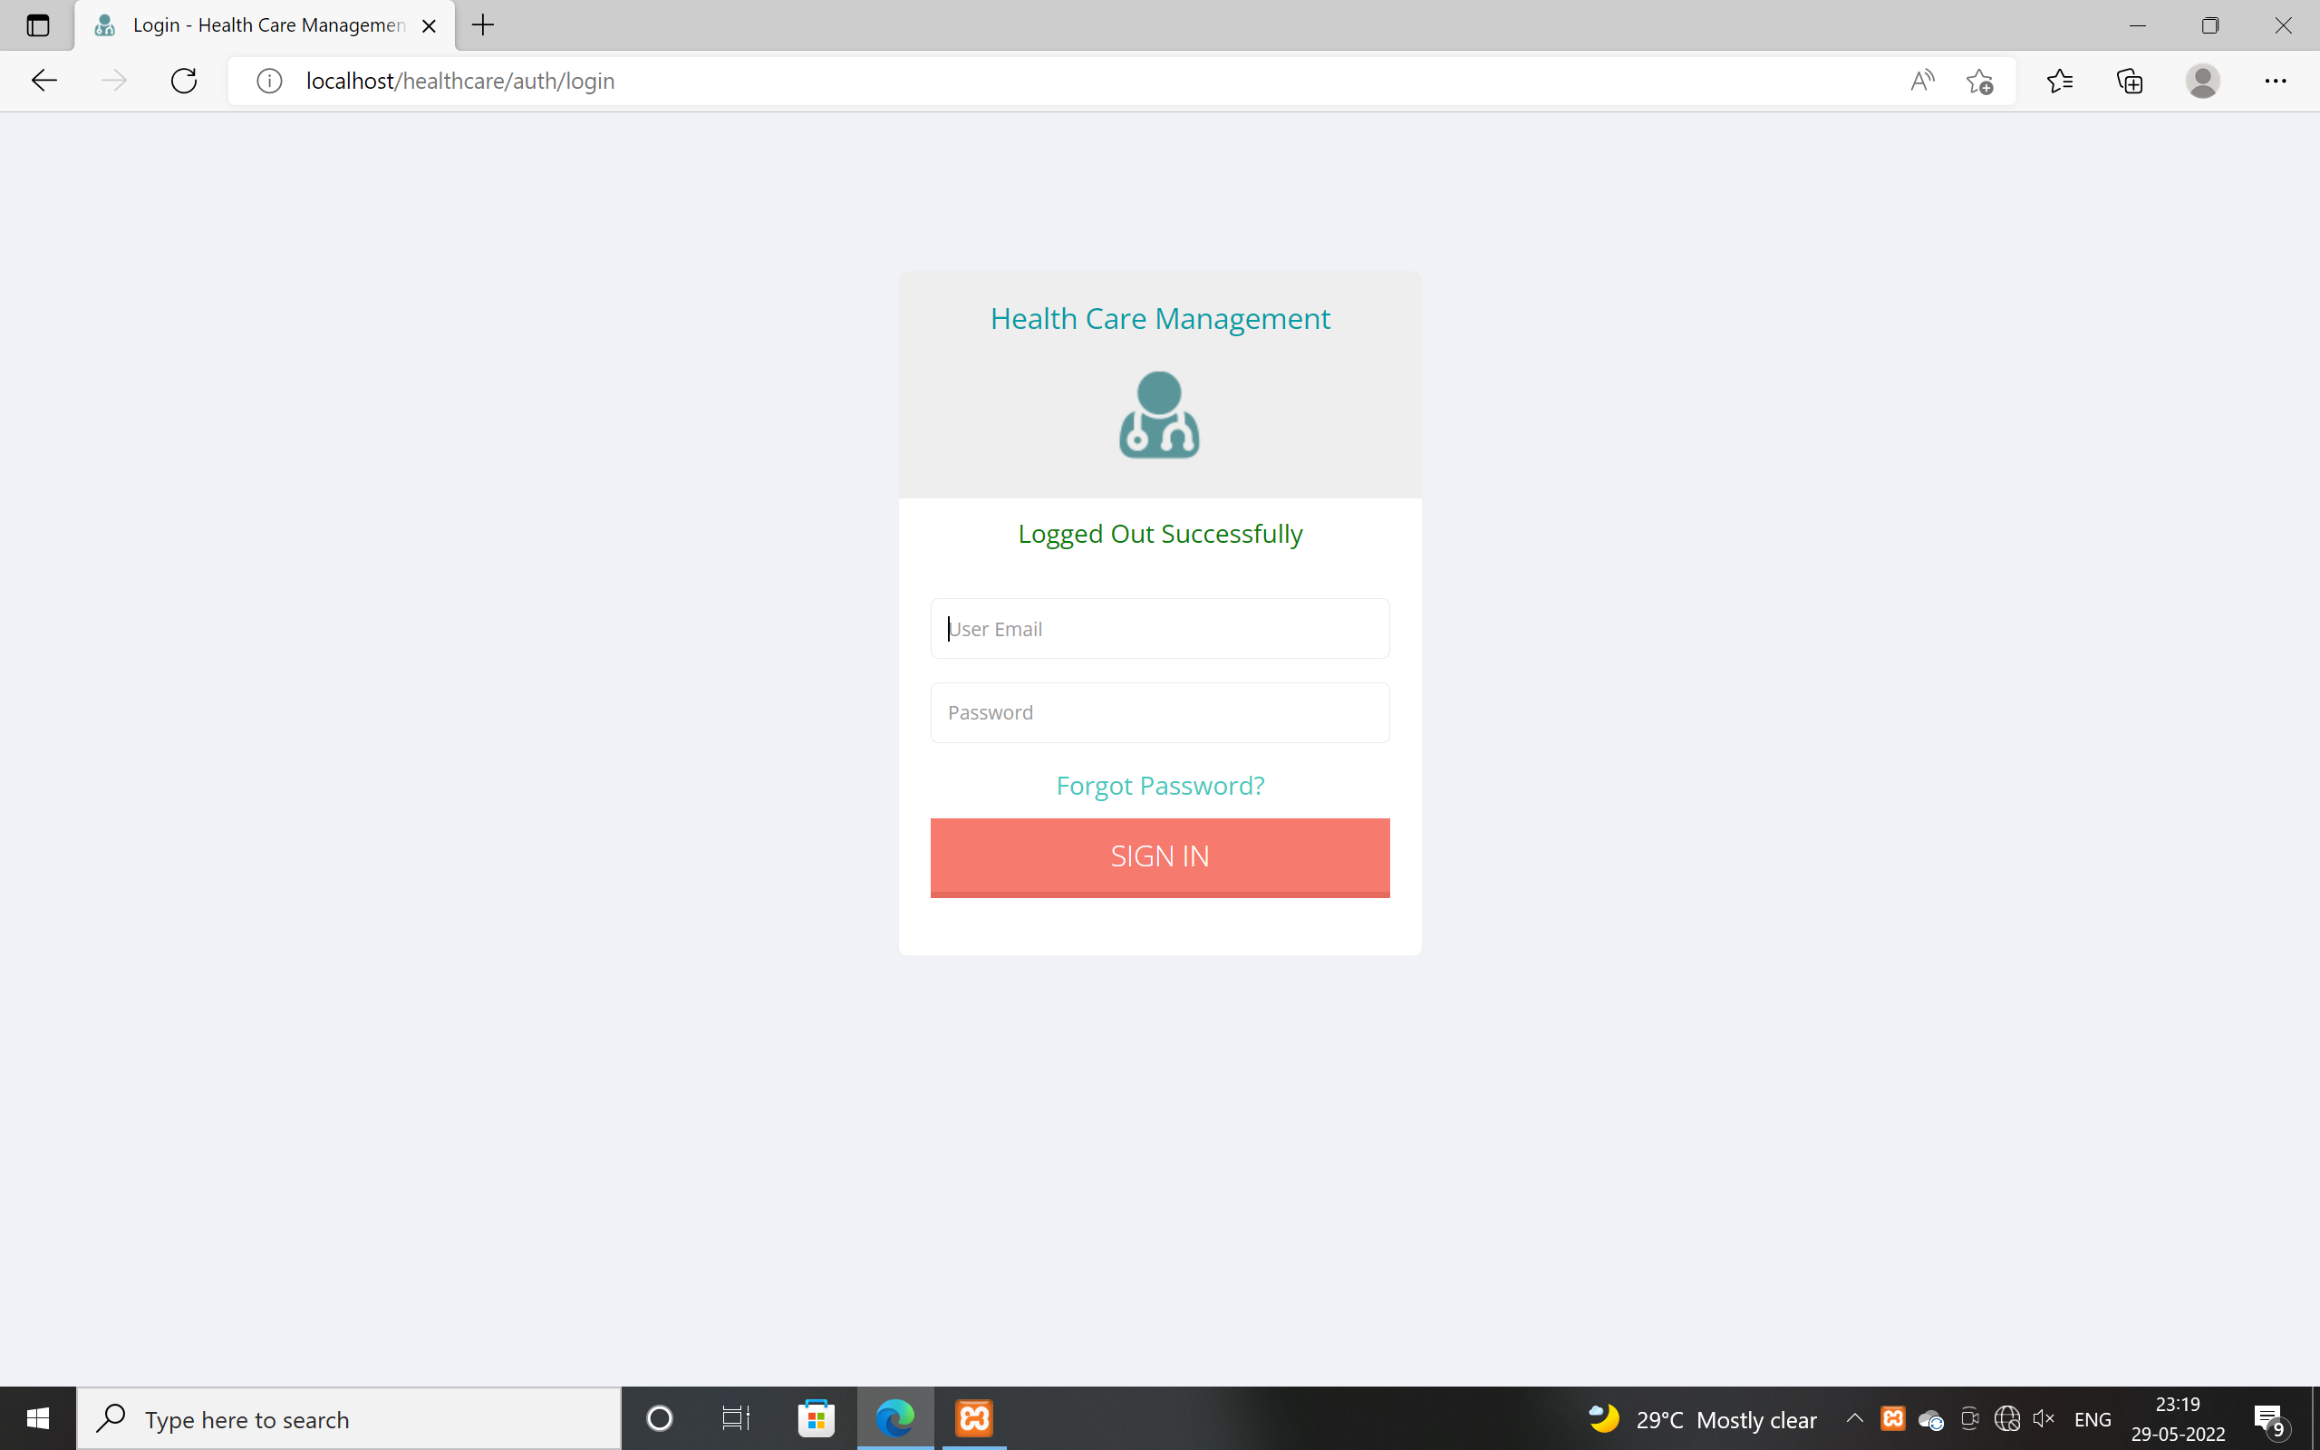

Incorrect login:

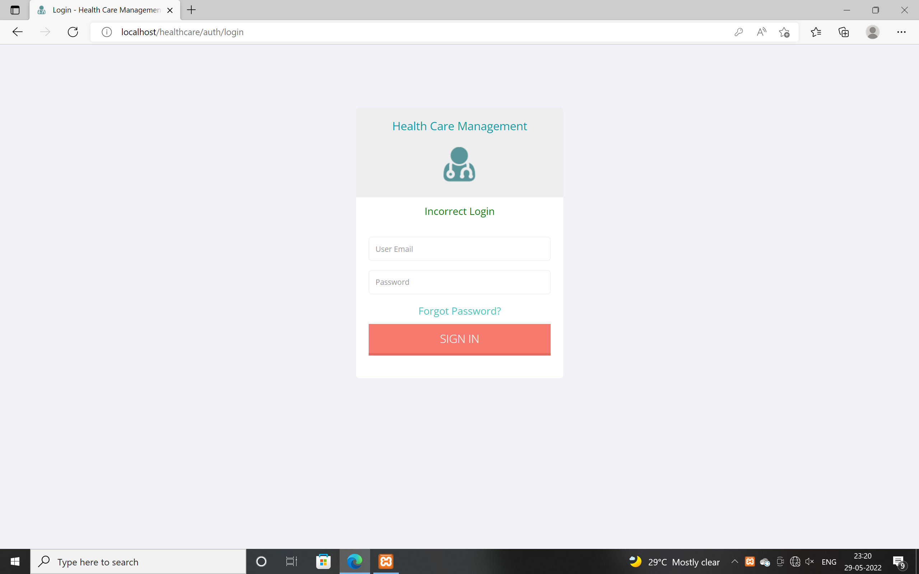

42

Super Admin:

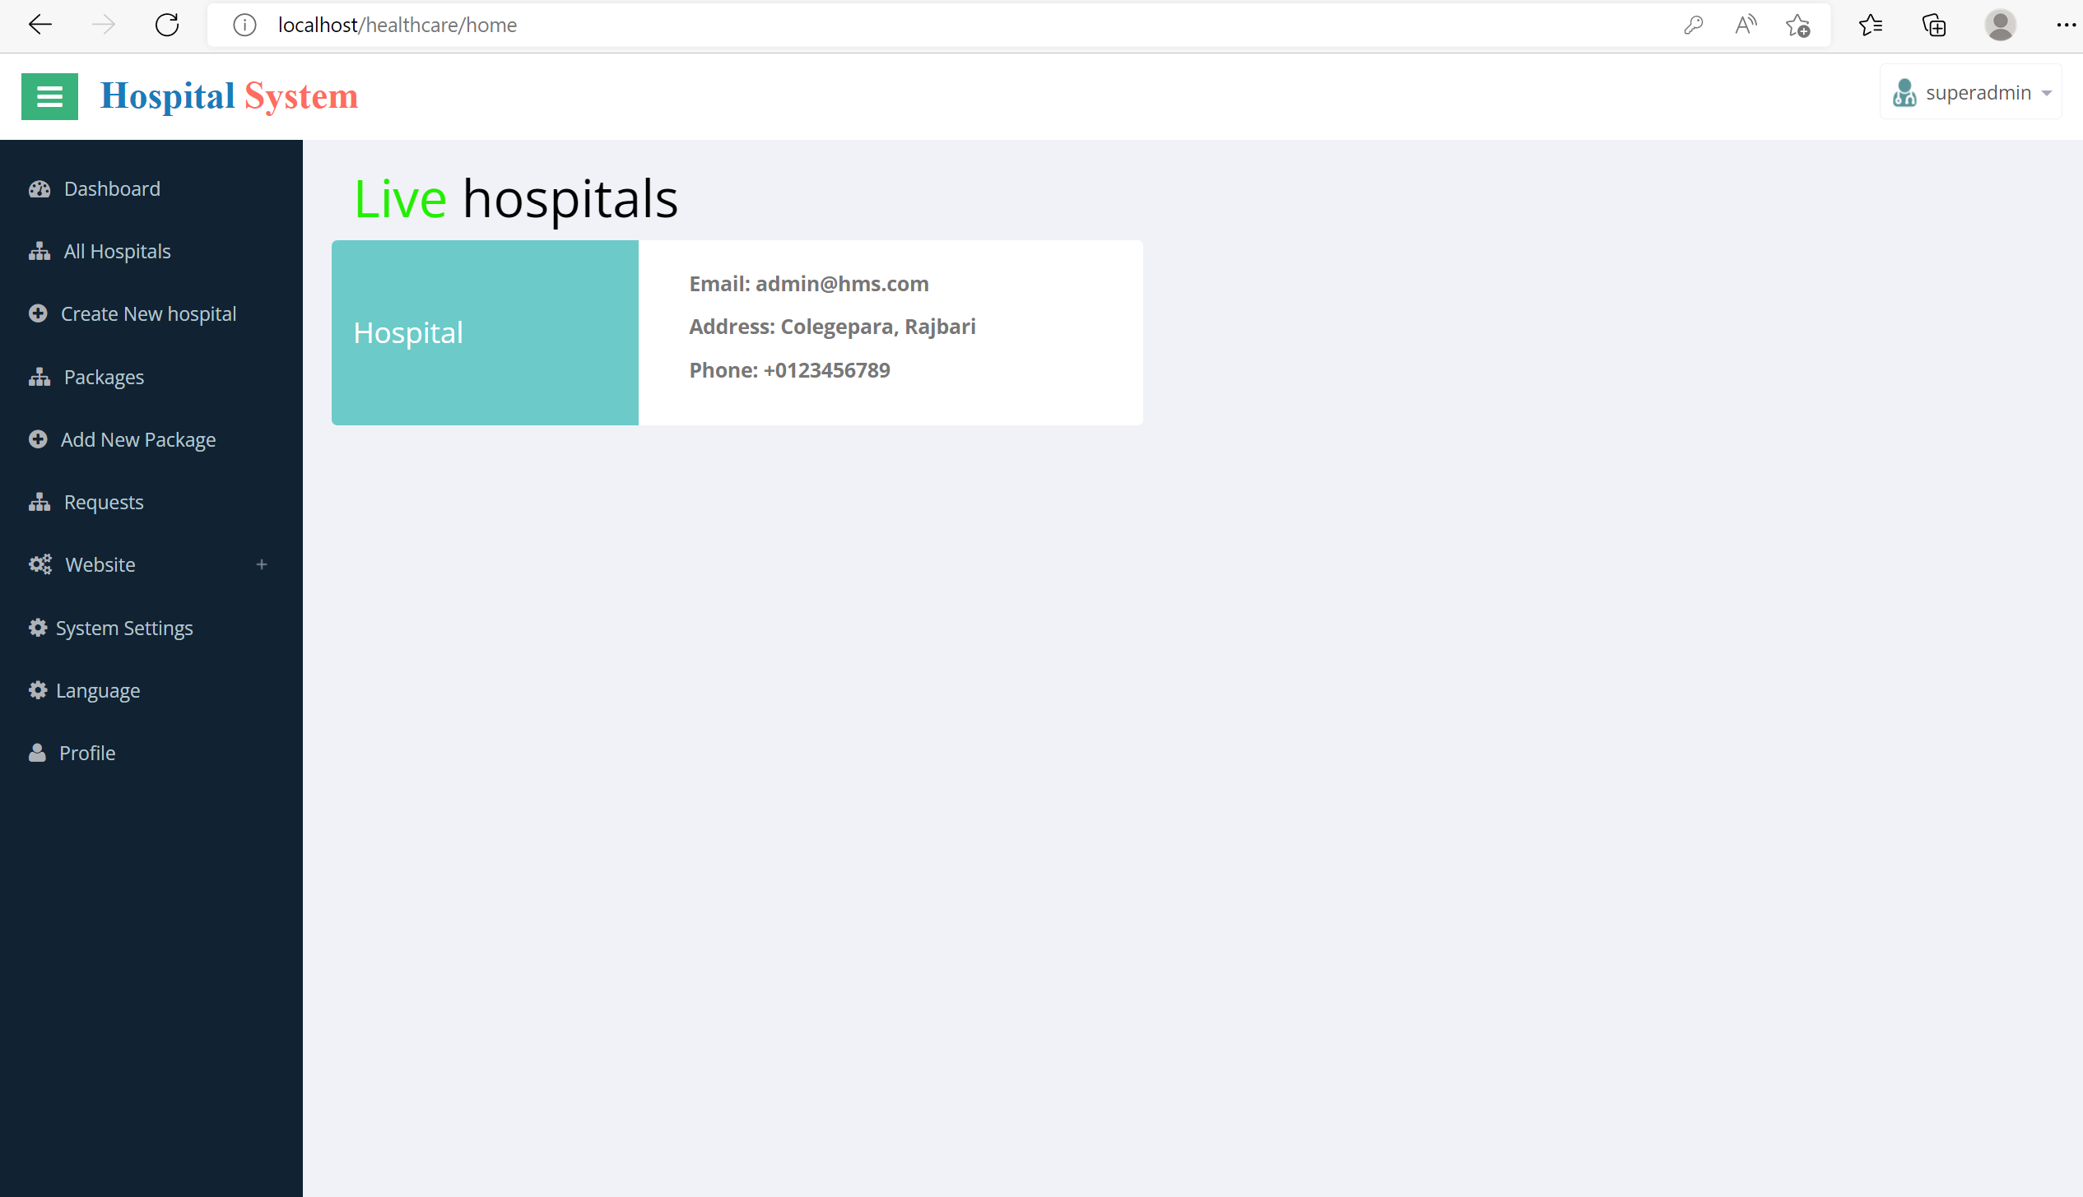

Admin:
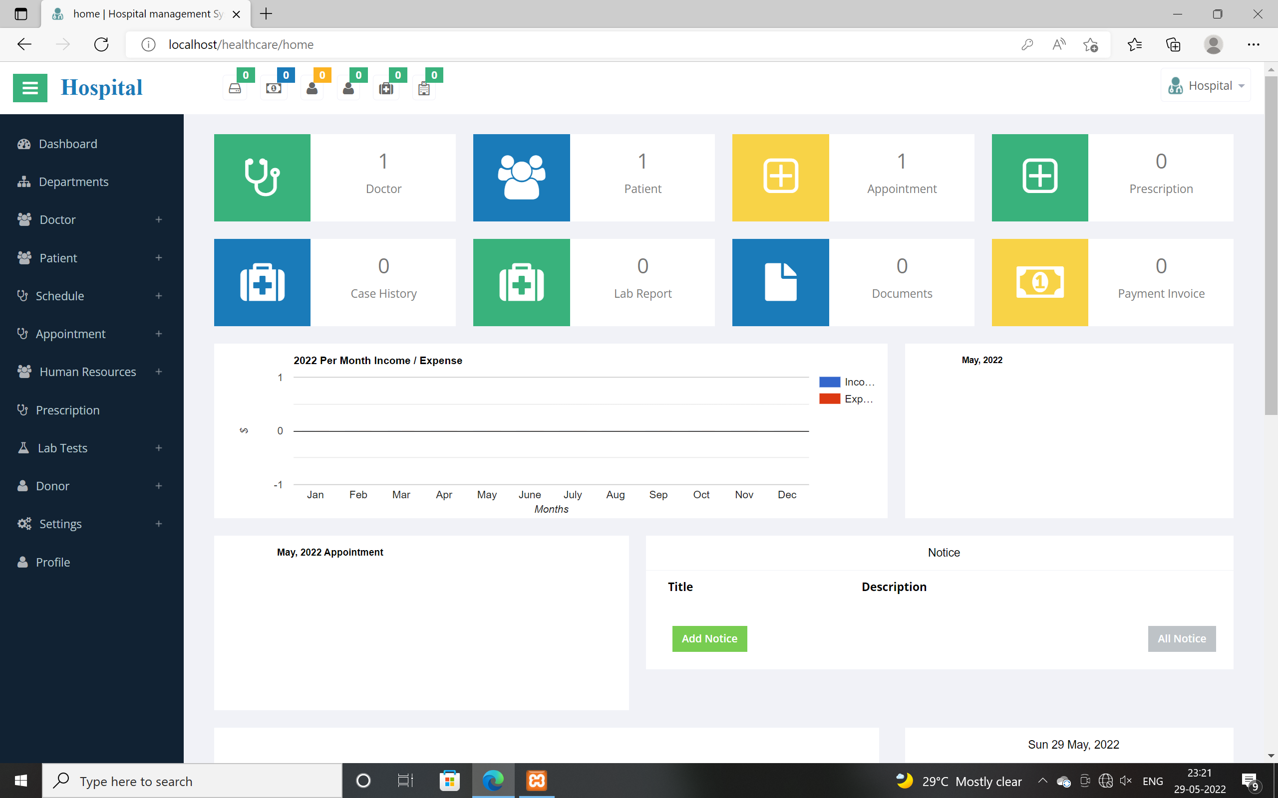

43

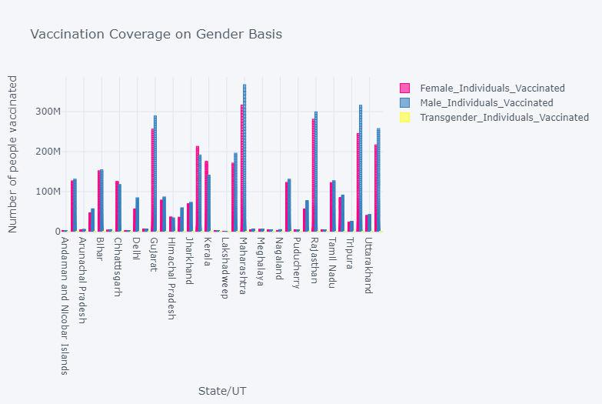

Doctor dashboard:

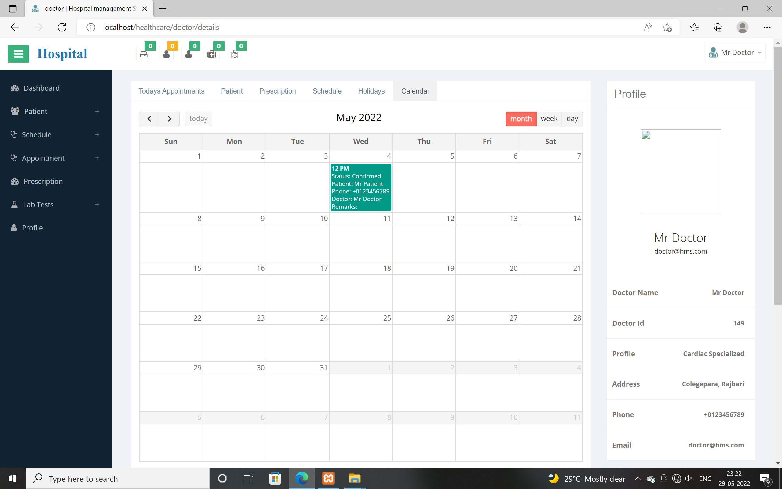

Patient Login:

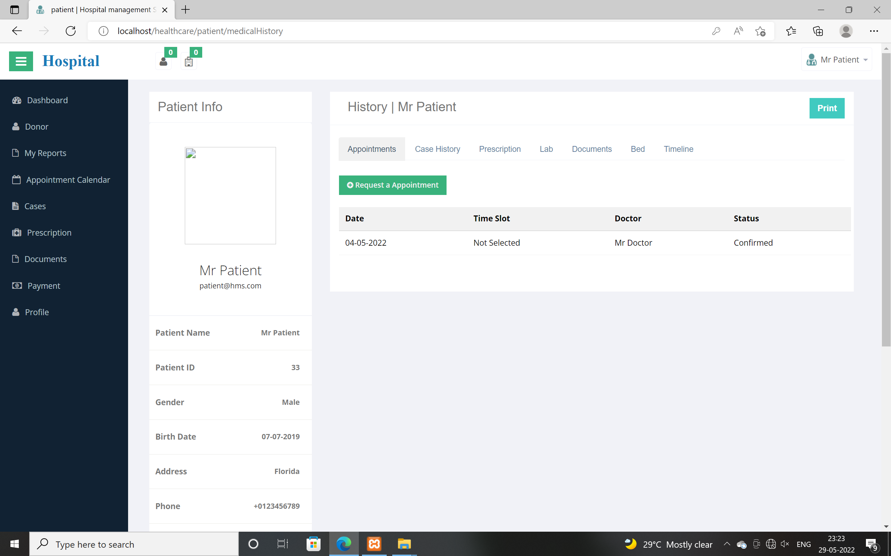

44

Nurse Login:

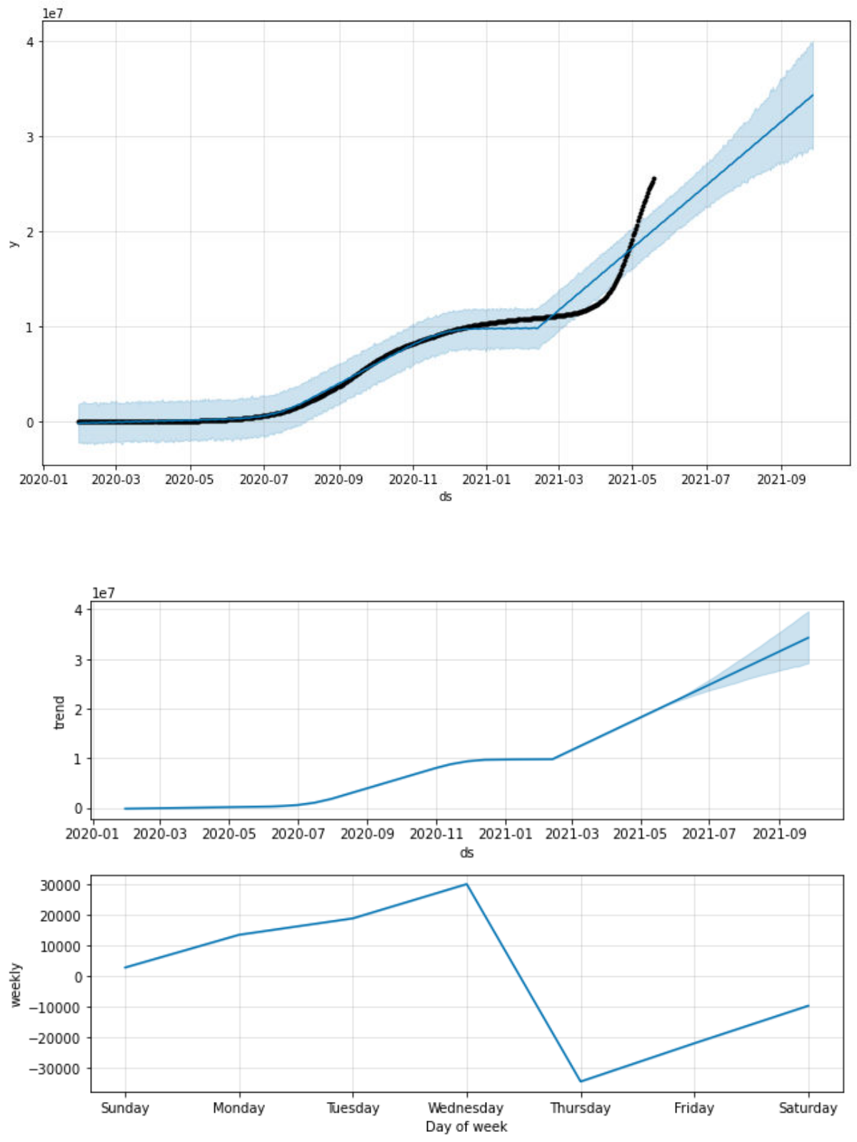

36

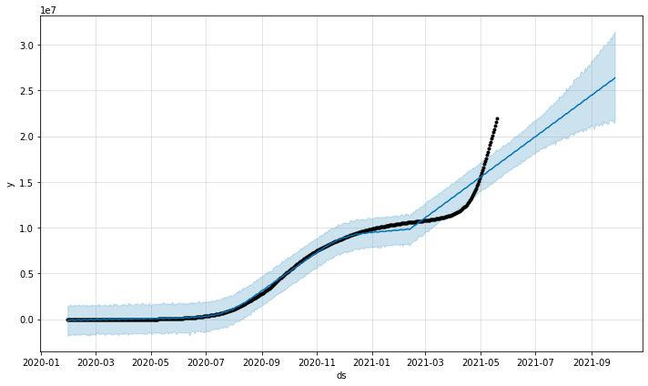
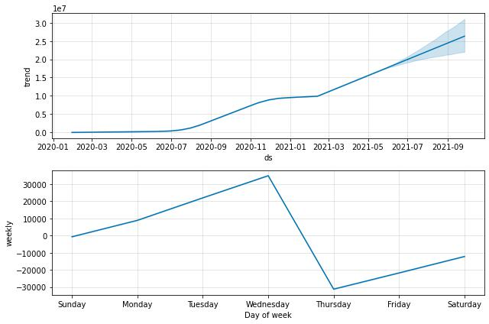

38

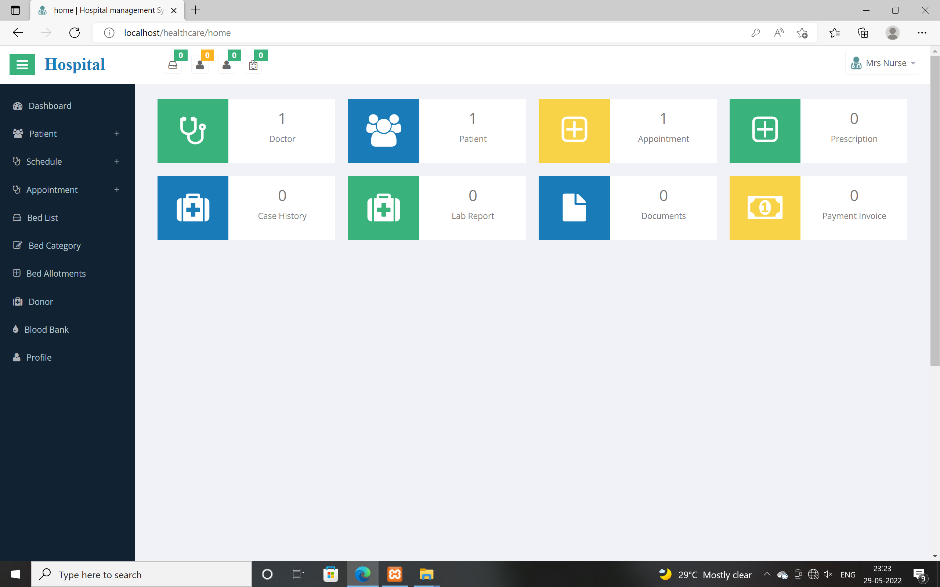

45
REFERENCES

- A Cluster Based System for analysing Ethereum Blockchain Transaction Data : Baran Kilic, Can Ozturan,Alper sen – 2020 Second International Conference on Blockchain Computing and Applications (BCCA).
- A Secure Healthcare System Design Framework using Blockchain Technology : Sabyasachi Chakraborty, Satyabrata Aich, Hee-Cheol Kim – 21st International Conference on Advanced Communication Technology (2019).
- Performance Analysis of a Hyperledger Fabric Blockchain Framework: Throughput, Latency and Scalability: Murat Kuzlu, Manisa Pipttanasomporn, Levent Gurses, Saifur Rahman - IEEE International Conference on Blockchain (2019).
- Semi-Centralized Blockchain Based Distributed System for Secure and Private Sharing of Electronic Health Records : Angst and Agarwal,“Adoption of electronic health records in the presence of privacy concerns: the elaboration likelihood model and individual persuasion,” MIS Q., vol. 33, no. 2, p. 339, 2017.
- Verizon, 2019 data breach investigations report, Verizon Bus. J., vol. 2019, no. 1, pp. 160, 2019.
- J. Adamu, R. Hamza, and M. Rosli, “Security issues and framework of electronic medical record: a review,” Bulletin of Electrical Engineering and Informatics., vol. 9, no. 2, p. 565 572, 2020.
- A. C. D. Paul, N. Spence, and N. Bhardwa, “Healthcare facilities: another target for ransomware attacks,” 54th Annu. MBAA Conf., 2018.

46

